The Babcock & Wilcox Company
Shipment Documentation
& Packaging Specification

Masinloc Power Plant Expansion Project
Barangay Bani near Masinloc Town
Zambales Province, Philippines

B&W Project / Contract Nos.:

321K / 354-0160

TABLE OF CONTENTS
1.0 General 4

1.1 Scope 4
1.2 After Receipt of Purchase Order (PO) 5

2.0 THE B&W SHIPMENT PROCESS 5

2.1 General Information 5
2.2 Document Submittal 6
2.3 Pre-shipment Inspection 6
2.4 Shipment Release 6

3.0 PREPARATION OF MATERIALS BEFORE PACKING 6

4.0 PACKING REQUIREMENTS 8

4.1 General Packing Requirements 8
4.2 Protective Packing 10
4.3 Hazardous or Poisonous Cargo 12
4.4 Seaworthy Packing 12
4.5 Wooden Framed Box or Crate 13
4.6 Skid Mounted Construction 13
4.8 Bare Materials 14
4.9 Containerized Cargo 14
4.10 Shrink Wrapping 15
4.11 Documents attached to the package 15

5.0 MARKING & IDENTIFICATION REQUIREMENTS 15

5.1 Main Shipping Marks 15
5.2 Cargo Marking 15
5.3 Auxiliary Shipping Marks 17

6.0 PACKING INSPECTIONS 17

7.0 DOCUMENTATION REQUIREMENTS & DISTRIBUTION 17

7.1 Listing of Ship Units (LSU) 17
7.2 Package/Ship Unit Numbering 18
7.3 Preliminary Packing Lists 18
7.4 Babcock & Wilcox Packing List (PL) 19

8.0 DELIVERY 19

8.1 Time and Place 19
8.2 Transport Documents 21
8.3 Bill of Lading (Proof of Shipment) 22
8.4 Other Documentation and Distribution Requirements 22

Appendix I: Box & Crate Construction 24
Appendix II: Major Frame Construction of Box or Crate 25
Appendix III: Skid Mounted Construction 26
Appendix IV: Steel Bundle & Wooden Bundle 27
Appendix V: Position of Main & Auxiliary Shipping Marks 28
Appendix VI: Markings Specification for Boxes, Crates, & Shrink 29
Appendix VII: Auxiliary Shipping Marks 30

1.0 General

This specification has been prepared to assure the packing quality and to state the minimum requirements for this project. It is intended for all Babcock & Wilcox (B&W) suppliers to facilitate meeting the terms and conditions of the Masinloc Power Plant Expansion Project. Failure to comply with these minimum requirements and instructions may result in back charges to the Seller.

The Seller is responsible for transmitting these packaging, shipping and documentation instructions to any sub-supplier engaged by the Seller.

“Purchaser” means “Contractor” or Buyer
“Supplier” means “Vendor” or “Subcontractor” or Seller

Project Identifiers:

B&W’s Customer: POSCO Engineering & Construction Co., Ltd.
B&W Project Number: 321K
B&W Contract Number: 354-0160
Project Location: Barangay Bani near Masinloc Town
Zambales Province, Philippines

Logistics Contact:

The Seller shall contact the B&W Logistics Coordinator listed below for any questions regarding the requirements and instructions in this specification.

Marie E. Brehob
mebrehob@babcock.com
Phone: (330) 860-1481

1.1 Scope

This manual shall be applied to all materials procured by Purchaser. Any deviation shall be requested in advance in writing, and formal written approval from Purchaser shall be obtained prior to proceeding. In case the Seller has its own standard manual, it can be submitted for approval by the Purchaser. The Seller is responsible for packing, and packing costs shall be included in the Purchase Order price.

Supplier shall execute packing distribution and any action related to packing process. Wood Packing Material (WPM) must be suited to the rule or the regulation for specific importing and exporting countries. WPM shall be mothproofed and must be suited to the regulation for customs clearance. Supplier must warrant any defect such as loss or damage of equipment up to its obligation upon contract delivery term.

1.2 After Receipt of Purchase Order (PO)

Within one month after receipt of the PO, the Seller shall submit one of the following two (2) sets of documents to Purchaser.

- When the Seller’s packing plan involves no deviation in any manner whatsoever from the requirements set forth in this specification, the Seller shall issue a written statement to the Purchaser to this effect.

- When the Seller’s packing plan deviates from the requirements of this specification, the Seller shall submit for Purchaser’s review, detailed package drawings and specifications indicating the size of frames, individual packages and skid mounted equipment. After contract, no additional cost will be accepted by Purchaser for the Supplier’s provision of export packing meeting or exceeding the requirements of this specification. Furthermore, the Supplier shall not be released from its obligations to provide export packing within the minimum stipulations of this specification, unless alternative measures proposed by the Supplier are approved and confirmed in writing as an acceptable substitute by Purchaser.

- Purchaser reserves the right to reject all materials offered during the delivery by the Supplier until export packing of an acceptable, satisfactory and approved standard are provided by the Supplier.

2.0 THE B&W SHIPMENT PROCESS

2.1 General Information

The Seller shall not ship materials until released by Babcock & Wilcox. No goods will be considered as ready for shipment until all of the pre-shipment requirements of the purchase order and this specification have been completed. Unauthorized shipments can be refused and returned at the Seller’s expense. Partial shipments are not permitted unless the Seller receives prior authorization from B&W.

2.2 Document Submittal

The Seller shall submit all documents required in the B&W Purchase Order. The Listing of Ship Units (LSU) and the B&W project-specific packing list (PL) forms and instructions for completion are available at http://www.babcock.com/supplier/. The LSU and PL’s must be submitted in Excel format as email attachments to bdoccntl@babcock.com.

2.3 Pre-shipment Inspection

B&W or its designee reserves the right to inspect the equipment prior to shipment and to defer shipment if equipment is determined by B&W or its designee not to be in conformance with the specification. Seller shall provide B&W a notification of inspection 10 days prior to such inspection.

2.4 Shipment Release

Getting a release to ship depends on many factors and requirements in the purchase order. In general, after all pre-shipment inspection issues have been resolved and any required documentation such as quality certificates, test reports, etc. have been submitted and approved, the Seller will receive the consignment address and routing information upon submission and approval of the Babcock & Wilcox packing list. The submittal must include a contact name, email address, and phone number for the person submitting the information.

3.0 PREPARATION OF MATERIALS BEFORE PACKING

3.1 All materials should be dry, clean and free from all defects prior to packing protection against environmental corrosion caused by extremes of humidity, condensation, rain, dust, sand, salted air and sea spray. The following requirements may be considered as minimum essential protective measure for materials:

3.1.1 Protect all external threads greater than 1” diameter from physical damage with a suitable non-hygroscopic thread protection material such as plastic shielding, wax impregnated fiberboard, or other suitable protective material. Materials such as untreated fiberboard or wood shall not be in direct contact with metal surfaces.

3.1.2 Flanged openings shall be covered with Plywood (Minimum thickness 5.5mm) or metal plates and attached with at least four bolts. Covers tied on with wire are not acceptable. For metal covers, appropriated gaskets shall be used between the flange face and the cover. For Plywood covers, the joint with the flange shall be sealed with waterproof adhesive tape.

3.1.3 Small loose parts shall be packed in separate boxes inside the main Package. Flexible connections shall be disconnected, and either tied to the main body or packed in separate boxes within the main package.

3.1.4 Small or sophisticated parts of instruments and electric equipment shall be packed in waterproof cartons or boxes and placed inside the appropriate main package. Special attention shall be made to prevent damage from moisture as well as vibrating during transportation.

3.1.5 Open ends of threaded or plain pipes shall be protected with metal or plastic caps or plugs.

3.1.6 Vapor phase inhibiting oil, vapor phase inhibiting powder or silica gel shall be used to protect all internal metallic surfaces of equipment. The type and quantity of vapor phase inhibiting oil, vapor phase inhibiting powder or silica enclosed shall be clearly stated outside the equipment.

3.1.7 Pressure Vessels and Heat Exchangers, if required, each consignment including those supplied as parts of rotating equipment or package units shall be purged and filled with an inert gas (e.g., Nitrogen).

3.1.8 Porous bags filled with desiccant shall be hung inside the covers of all main connection openings of rotating equipment. All threaded pipe ends shall be sealed with threaded metal Plugs or Cap. The quantity of desiccant enclosed (e.g., number of bags) should be clearly marked on exterior of equipment.

3.1.9 Desiccant - Best if used in closed/sealed moisture barrier, or a rigid/sealed container. Desiccant cannot be used is the same enclosed space as VCI (Volatile Corrosion Inhibitor) Products. Desiccant must not contact the commodity, and should be evenly dispersed within the package. See Primary types below: In selecting a desiccant the following must be considered: the air space size, the nature/type of the material to be used, the moisture surrounding the package, the desired shelf/storage life, the atmospheric conditions when/where the package is sealed.
- The minimum quantity of desiccant to be placed inside a bag shall be determined from the manufactures recommendation.
- In large enclosed areas desiccant bags will be suspended to allow moisture collection away from material.
- Clay Desiccants - are made from montmorillonite clay, which have a special affinity for moisture. Clay desiccants are naturally occurring, non-hazardous, moisture adsorbent substances. This clay is chemically inert and non-corrosive. The layered structure attracts and adsorbs moisture onto the surface and between the layers of the clay.
- Silica Gel - is silicon dioxide (SiO2), an amorphous form of silica. Two important properties of silica gel are that it is non-toxic and non-corrosive.
- Molecular Sieve - is a manufactured crystalline version of Zeolite and is a non-hazardous material.

3.1.10 Humidity indicators - Humidity indicators must be used for items requiring ` desiccant. Place humidity indicator behind an inspection window or immediately within the closing edge of the barrier material and as far as practicable from the nearest unit of desiccant. Use a three-spot paper card type 1x4 inches in size or approved alternative. The spots indicate relative humidity of 30 percent, 20 percent, and 10 percent, top to bottom, by changing color from blue to pink.

4.0 PACKING REQUIREMENTS

4.1 General Packing Requirements

4.1.1 The packing requirements in this section cover the consideration for site environmental preservation and the minimum requirement for protecting materials by utilizing inside fastening and/or a moisture barrier application. If these requirements are incomplete, the best packing practice shall be proposed in order to ensure that all the material arrives at the destination in undamaged conditions. Packing shall include preservatives suitable to weather conditions.

4.1.2 Seaworthy packing shall be required to protect the imported/exported equipment and materials against damage during transportation.

4.1.3 Packaging has to be carried out under the most technical, up-to-date method.

4.1.4 Equipment/Components shall be packed in one or more boxes bearing unique package identification numbers.

4.1.5 Electrical and I&C equipment must be packed separate from other components.

4.1.6 All equipment requiring indoor storage must be clearly identified.

4.1.7 The Supplier shall include and provide for securely protecting and packing the materials so as to avoid loss or damage during handling & transport by air, sea, rail and road. Special precaution shall be taken to prevent rusting of steel and iron parts during transit by sea. Gas seals or other materials shall be adopted by the Supplier for protection against moisture during transit till its arrival at Project Site.
4.1.8 Equipment and materials, when applicable, are to be coated with recognized rust preventative suited for the particular application concerned. All internal parts of machinery shall be treated with lubricant containing rust and oxidation inhibitors to protect equipment. Such lubricant shall be compatible with those that will subsequently be used in service and should be identified by appropriate tagging.

4.1.9 Export packaging shall include preservatives suitable to rainy weather conditions consistent with a tropical environment in the Philippines for a period of one (1) year.

4.1.10 In case the equipment/material is susceptible to damage or corrosion by exposure
to moisture, the cases should be lined with waterproof material and moisture
absorbents, as required.

4.1.11 Each package delivered for this project shall be marked by, and at the expense of, the Supplier and such marking must be distinct and in English language (all previous irrelevant markings being carefully obliterated). Such marking shall show the name and address of consignee, the gross weight and net weight of the package, Seller, and Contract number (refer to Appendixes).

4.1.12 Besides wherever necessary, packing shall bear a special marking “TOP”, ”BOTTOM”, “DO NOT OVERTURN”, “KEEP DRY”, “HANDLE WITH CARE”,
“FRAGILE” etc. according to the appendixes requirements. See Appendix VII.

4.1.13 Individual package numbers will be assigned for each package by the Purchaser.
4.1.14 Purchaser or the authorized representatives have the right to inspect all packing prior to dispatch, and ask for modifications, as mutually agreed.

4.1.15 Purchaser reserves the right to reject packaging materials not suitable for export packing per industrial standards offered by the Seller.

4.1.16 ISPM 15 Wood Packaging Material Regulations

The material and equipment for this project will be shipping to the Philippines which has adopted regulations based on the International Standards for Phytosanitary Measures, commonly referred to as ISPM 15 standards for solid wood packaging materials (SWPM).

In case of wood packing, the requirement for the attached “International Standards for Phytosanitary Measures” shall be satisfied. The marking for Phytosanitary Measures should be stamped on all packing material (including pallets, dunnage, crating, packing blocks, drums, cases, load boards, pallet collars, etc.)

Example of IPPC mark:
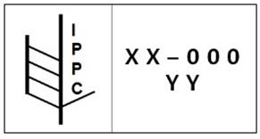

4.2 Protective Packing

4.2.1 All materials used for packing shall be new, supplied free by the Seller and will be required unless otherwise stated in the P.O.

4.2.2 All materials to be packed should be clean, dry, and free from all defects against environmental corrosion caused by extremes of humidity, condensation, rain, dust, sand, salt air and sea spray.

4.2.3 For the equipment transported by sea, the packing should be seaworthy. Special precaution shall be taken to minimize rusting of steel and iron parts during transit by sea. Gas seals or other materials shall be adopted by the Supplier for protection against moisture during transit until its arrival at the Project Site.

4.2.4 Heavy machinery shall be mounted and bolted to skids that shall be of sufficient strength to support and prevent distortion to the machine. All openings of pipes, tubes, hoses, flanges, connections, large valves, machinery, etc. must be covered or plugged. Machined threads must be covered by caps to protect against damage in transit.

4.2.5 Machine finished surfaces shall be coated with approved anti-rust compound and all equipment and parts susceptible to corrosion by exposure to moisture shall be given one coat of special rust protective paint suitable for twelve (12) months storage.

4.2.6 In addition to normal packing, all electrical equipment shall be wrapped in polythene or polypropylene plastic sheet and all openings in electrical equipment shall be sealed with waterproof tapes. A protective greaseproof paper shall be inserted between the brushes and armatures of motors and generators.

4.2.7 Fragile items shall be wrapped in crepe cellulose wadding or some equally efficient cushioning material and floated in excelsior and packed in substantially strong wooden covers with special precaution against risk of breakage.

4.2.8 Cable shall be properly wound on drums with adequate stiffening and protective braces and coverage so as to protect the cable from damage during transit, rain etc. Cable ends shall be sealed properly.

4.2.9 All wooden boxes shall be securely wrapped and fastened with steel straps.

4.2.10 For box or crate packaging, each box or crate shall support the weight of one additional box or crate of similar weight and dimensions.

4.2.11 Steel plates have to be lined with suitable cushion material to avoid scrubbing of the paint or prime coating.

4.2.12 Parts prone to corrosion and sensitive parts must be welded into suitable foil (e.g., PVC <polyvinyl chloride> foil must not be used) with drying agent added, and packed into wooden boxes.

4.2.13 The contents of boxes must be supported and secured against shifting and sliding which might result from sharp buffeting load and similar.

4.2.14 Pipes that are sensitive due to their nature of material, wall thickness, surface treatment, etc., must be bundled and packed in wooden boxes.

4.2.15 Moisture-proof packing for control panels, electronic equipment, etc. shall be done as follows:
- Moisture-proof barrier materials such as Al foils shall be used. The air shall be eliminated by used vacuum cleaner or other suitable means. Care shall be taken to minimize the air contained in the barrier.
- Projecting parts shall be protected not to damage the moisture-proof barrier foils.
- The moisture-proof barrier shall then be hot sealed following the nitrogen gas purging.

4.2.16 The following items shall be packed in separate inner boxes from the main item.
  - Spare Parts for Start-up & Commissioning
  - Spare Parts for Two (2) years of operation (Option)
  - Special Tools
  - Consumables

4.2.17 Start-up and Commissioning spare parts shall be individually tagged and marked.

4.2.18 Temporary facility, supports, name plate, etc. shall be marked and painted with distinguished color in order to know easily at site.

4.2.19 Unless otherwise specified, after hydrostatic test, operation and/or performance test, all fluids, such as, lubricating oil, fuel oil water, etc. shall be completely drained from all tanks, vessels, jacketing, piping, etc. and wiped or blown dry.

4.3 Hazardous or Poisonous Cargo

When dangerous goods have to be delivered like Explosives, Gases, Flammable Liquids and Solids, Oxidizers, Poisons, Radioactive, Corrosive or other dangerous goods, these items must be packed and loaded in conformity with actually valid regulations and laws, and the packages have to be loaded separately as necessary.

- A written and duly signed Dangerous Goods Declaration containing class according to regulations of the Inter-governmental Maritime IATA/ICAO dangerous goods regulations will be provided once the cargo is packaged and submitted in accordance with the commercial specification.
- Cargo contents and explanation of chemical or hazardous nature, for example, flammable material, pressurized container.
- Quantity of Goods and packing style and specifications.
- Catalog

4.4 Seaworthy Packing

The Supplier shall suitably pack all materials and make every effort to ensure that all packages are as compact and durable as possible. Except for dangerous or hazardous items, if possible, each consignment should be made into packages not less than 200 kg or not less than 0.5 cubic meters in volume. All packages shall be properly and solidly made to be suitable for all mechanical and inland transportation. All package design and construction shall also take into account the following eventualities:
- Handling at the loading and unloading port multiple times;
- Outdoor storage after shipment to job site for the maximum of 12 months;
- Significant variation in ambient temperature during ocean shipment;
- Because two storages in ship’s hatches cannot be ensured, provision for supporting and overburden of three layers for pressure part and structure steel and two layers of general cargo shall be included in package design and construction.

4.5 Wooden Framed Box or Crate

The construction of wooden framed boxes or crates shall be based on industry accepted practices, as demonstrated in Appendix I & II. Materials shall be securely bolted to the box or crate floor and restrained in such a manner as not to permit any movement or vibrating during transportation. When moisture proof wooden cases are provided or the materials are hermetically sealed in polyethylene or similar covering, appropriate ventilation openings shall be incorporated into the case sides.

4.6 Skid Mounted Construction

Lengthy equipment, such as Columns, Tower, Drum, Vessels, and Heat Exchangers may be shipped bare, mounted on skids in position with steel wire ropes or flat steel bars as shown in Appendix III. The following requirements shall be considered for mounted skid construction:

- The size and position of the skids are subject to the minimum requirements given in Appendix III and should be sufficient to ensure safe handling during long distance transportation. Steel wire ropes shall be appropriately tensioned taking into account possible slack caused by wood shrinkage.
- The maximum distance between skids shall be 8 meters.
- When using skids made of two or more pieces of lumber, bolts shall be used. Fastening by wire is strictly prohibited.
- For equipment with either weights in excess of 15 tons or with a plate thickness of 8mm or less, areas where sling rope and metal surface come into contact shall be covered and protected with wooden slats.
- Strips of non-combustible materials such as polypropylene cloth shall be placed between skids and materials, and between restraining straps/wires and materials.
4.7 Bundles

Small diameter pipes, structural steel, and other lengthy material shall be bundled and tied with steel wire or steel bands at the center and both ends as shown in Appendix IV. For cement or bituminous lined pipes, wooden slats shall be provided for loading and discharging. The Supplier shall submit a detailed plan for transportation.

When using steel bands a non-combustible cushion material such as polypropylene cloth shall be placed between the steel band and the material to prevent damage or rusting. Ends requiring protection or where items may be likely to drop out shall be covered with polypropylene cloth a minimum length of 800mm before being bundled (refer to Appendix IV). For a wooden bundle, an additional wooden bar shall be nailed to each of the upper wooden bars to prevent either the bolt ends or the cargo being damaged when stacked (refer to Appendix IV). The bundles shall be sealed together top and bottom by means of U-shaped iron which are bolted together with threaded rods, nuts and lock nuts so that no parts can be loose even when the bundle is tilted.

4.8 Bare Materials
For materials permitted to be shipped bare, i.e. without packing, any projections on the materials closed to the sling points shall be adequately protected against possible damage by sling wires (refer to Appendix IV).

4.9 Containerized Cargo
Instrument and sophisticated electrical panel nominated by Purchaser shall be stuffed in dry containers in order to protect from damage. The inside dimension of the container shall be considered as following when manufacturing the packages.

(1) 20FT container: 580 x 220 x 205㎝ (L x W x H)
(2) 40FT container: 1180 x 220 x 205㎝ (L x W x H)

When the Supplier considers containerization as the most appropriate mode of shipment, a proforma packing list should be handed over and approved by Purchaser.
To the extent applicable to the Seller’s scope of works, Seller shall comply with the national traffic regulation of the Country concerning weight limitations on container cargo; that is, maximum weight of 17.5 metric tons for a 20 foot container and 20 metric tons for a 40 foot container.

4.10 Shrink Wrapping
Fire bricks, castables, and insulating materials may be shrink-wrapped. The maximum weight of each shrink-wrapped package shall be limited to 1.4 tons.

4.11 Documents attached to the package
Each consignment shall be accompanied with two copies of the packing list. One copy of the above packing list shall be placed inside the crate or package and other in a watertight envelope outside the package or crate and shall be placed in such a manner not to be separated or lost during shipment.

5.0 MARKING & IDENTIFICATION REQUIREMENTS

5.1 Main Shipping Marks
The following details must be clearly and properly stenciled on at least two sides of each box/package with good quality non-fading indelible ink/paint in characters approximately 150mm high (depending upon size of the packages). All markings must be in English.

The frame of the container or package shall be commensurate with the size of
the container or package, and the marking shall include the following information in sequence:
A. The name "POSCO E&C";
B. The Contract name and number; Masinloc 2015FS0103
C. The port of destination;
D. The Invoice number or if any, the Letter of Credit number;
E. The item and package number in sequence and quantity per package;
F. The commodity description;
G. The net weight, gross weight and cubic measurement;
H. The shipper's name and marks;
I. The origin of the Equipment;
J. Caution marks, if necessary;
K. Color marking as instructed in the Appendix VI; and
L. The identification number or reference number to be instructed by the Buyer

5.2 Cargo Marking

5.2.1 Unique assigned package numbers will be issued to Supplier by Purchaser for each package.

5.2.2 Each package delivered shall be marked, must be distinct and in English. Such markings shall show the name and address of the consignee, the gross weight and net weight of the package, Seller, and Contract number. See Appendix V for placement of markings.
5.2.3 When shipping marks are made of plywood, the care points shall be marked with an waterproof pen or paint. The shipping mark can be adhered to the plywood directly.

5.2.4 When shipping mark is made of paper, the shipping mark shall be printed and coated with pouch film.

5.2.5 When shipping mark is made of acetate vinyl, the care points shall be marked with an waterproof pen or paint. Secure the shipping mark with a stapler. The shipping mark borders will be fixed with a cellophane tape once again.

5.2.6 Marks can also be stenciled.

5.2.7 When the shipping mark is made of acetate vinyl or pouch film, in the case of bundles or skids, the shipping mark should be put in between the bundle or skid and steel bands.

5.2.8 When the acetate vinyl or pouch film type of shipping mark adhesion is impossible to attach to steel structure type of equipment, the sticker is used in lieu of shipping mark.

5.2.9 Packing List Cover (Steel case 170x 150mm) adhesion:

The packing list cover is adhered to the outside of package to identify easily. The packing list is wrapped up in transparent vinyl and kept with packing list cover. In case of Bundle and Skid type, the Packing List would be put into a vinyl bag with zipper, and then, it would be attached to Bundle and Skid by fluorescent tape.

5.2.10 Wherever required and due to unbalanced weight, the position of center of gravity shall be marked as appendix instruction.

5.2.11 In addition to the above, the packages containing items of the following nature shall be painted in black non-fading paint with the letter in capital as shown against respective items in characters approx. 150mm high at the right hand top corner.

NATURE OF ITEMS PACKED SYMBOL
a) Commissioning Items “C”
b) Tools and Tackles “T”
c) Operating Supplies “O”
d) Fast wearing items for operation & maintenance “S”

In the case of bundles, the markings are to be placed on metal tags which are to be securely attached to the bundle. Marking/Symbols for storage and handling must be indicated on packages covering the following:
- To be stored in covered area
- To be stored in outer yard with covered tarpaulin
- To be stored in outer yard without cover
- To be stored in air conditioned store
- Any other special precaution to be taken during storage
- Sling here
- Center of Gravity
- Use no hooks and do not puncture

5.3 Auxiliary Shipping Marks

To avoid delays in cargo handling and or event accidents, sling marks, center of gravity marks and lifting method shall be stenciled on only after the Supplier has actually lifted each package with a hook and ascertained each correct position.

6.0 PACKING INSPECTIONS

Purchaser or the authorized representatives have the right to inspect all packing prior to dispatch and ask for modifications as mutually agreed.

PURCHASER’S INSPECTION - Packing inspection may be made by Purchaser, Purchaser’s designated inspector, Posco E&C, AES’s Inspector and/or Insurer’s Inspector. Inspection shall be extended to a visual, dimensional quantity check of equipment and materials, etc.

SUPPLIER’S INSPECTION - Packing inspection shall be performed by Supplier or Supplier’s designee in accordance with the instructions described in this specification prepared by Purchaser before witness inspection stated hereunder. Supplier shall also inspect strength to bear various stresses during transportation and quality of the contents, etc. in each package on his own responsibility.

7.0 DOCUMENTATION REQUIREMENTS & DISTRIBUTION

7.1 Listing of Ship Units (LSU)

The Seller may be required to submit a listing of ship units to Babcock & Wilcox. This requirement is determined on an individual purchase order basis. The LSU form is a Microsoft Excel spreadsheet designed by B&W. The Seller does not need to know how the material will be packed at the time the listing of ship units is completed. The LSU form and instructions for completion are available at http://www.babcock.com/supplier/. Electronic submittal as an email attachment to bdoccntl@babcock.com is required.

7.2 Package/Ship Unit Numbering

Prior to submitting packing lists, the Seller must determine how many package numbers they need and contact the B&W Logistics Coordinator listed in section 1 to obtain the project-specific series of assigned numbers for their material. Each package (skid, crate, case, drum, etc.) or ship unit (loose piece, beam, etc.) will be assigned a unique, non-repetitive number referred to as the Assigned Package Number.

7.3 Preliminary Packing Lists

The Seller shall provide preliminary packing lists for all shipments within 30 days of the agreed Delivery Date of Equipment. For container shipments, the preliminary packing list will provide container size, weight and number of containers to enable Buyer to arrange cargo space. The final packing list for all shipments can be provided between five (5) to ten (10) days of shipment.

In case the Seller fails to provide the Buyer with the preliminary packing list thirty (30) days prior to the Delivery Date, all extra demonstrated and documented cost incurred by delay in confirmation of Delivery Date, shall also be reimbursed by the Seller in the foresaid manner if such delay is solely attributable to the Seller, provided however, these extra charges shall not apply or be payable by Seller unless and until such extra charges have been incurred and paid by the Buyer.

For break bulk shipments not in a shipping frame, the Seller shall provide the Buyer with information for transportation marking for lifting, lugging points, center of gravity, etc. at least three (3) months prior to the delivery date of each shipment. This requirement is applicable for equipment which has one or more of the following characteristics:
1) Where a single item weight, including packing, is greater than 30 metric
tonnes.
2) Where a single item, including packing, has a size in at least two directions
greater than a standard 40’ container (being 12 meters length, 2.5 meters wide, 2.5 meters high).

The Seller shall be liable for reimbursement of extra demonstrated and documented dead freight cost and packing reinforcement cost incurred by the Buyer due to the difference of revenue ton (greater cargo volume or weight) of 10% more or less between the packing lists submitted to the Buyer one (1) month prior to the Delivery Date and the actual cargo delivered provided however these extra costs shall not apply or be payable by Seller unless and until such extra costs have been incurred and paid by the Buyer. For the avoidance of doubt the Parties acknowledge and agree that Seller shall not be responsible for any extra costs for the +/- 10% difference of cargo volume or weight.

The Seller’s liability referenced in the above paragraphs shall apply only to boiler pressure parts and structural steel deliveries.

7.4 Babcock & Wilcox Packing List (PL)

A B&W project-specific packing list is required for each package or ship unit. One copy of the packing list must be placed inside the package. The project specific packing list form and instructions will be available at www.babcock.com/supplier. Select the contract name or contract number 354-0160 or 321K from the drop down box to obtain the packing list. The P/L is an Excel spreadsheet and must be submitted as an email attachment to bdoccntl@babcock.com is required. PDF versions of the P/L will not be accepted.

The Seller will be responsible for costs to resolve discrepancies between the Seller’s packing list descriptions and quantities and the actual material shipped.

8.0 DELIVERY

8.1 Time and Place

Unless otherwise agreed upon between both Parties hereto, the Seller shall deliver the Equipment to the specific point, named place or carrier nominated by the Buyer, on the basis of FCA Delivery Point for the FCA supply portion of the Equipment and, if necessary, on the basis of Delivery at Site for any in Country supply portion of the Equipment to be transported by truck, railway or vessel in accordance with the delivery schedule.

If the Buyer desires to adjust the delivery schedule, loading port and/or mode of transport, the Seller shall cooperate to a reasonable extent in order to adjust the delivery schedule and/or other conditions as the Buyer desires in accordance with the terms of the Contract.

The Seller shall not deliver the Equipment more than one (1) month prior to the delivery schedule specified in the Contract without the Buyer's prior written approval.

In the event that the Seller delivers the Equipment more than one (1) month prior to the delivery schedule specified in the Contract without the Buyer's prior written approval, the Seller shall bear all costs and expenses incurred therefrom.

Each Forwarder Cargo Receipt shall be issued by the Buyer when all three of the following conditions are met:

1) Equipment has been delivered to the Delivery Point.
2) Forwarder nominated by Buyer has visually inspected the Equipment and its condition is noted on the Forwarder Cargo Receipt.
3) Seller has submitted all transport documents as per 8.2

The issuing date of Forwarder Cargo Receipt shall be construed as the date of delivery provided that the Forwarder Cargo Receipt is issued on a daily basis.

The said liner loading ports are limited to Busan (for container cargo) or Masan (for bulk cargo) in Korea, Felixstowe in England; Le Havre in France; Rotterdam in the Netherlands; Antwerp in Belgium (only for container cargo); Hamburg and Bremerhaven in Germany; Long Beach in Los Angeles, Seattle, Oakland, New York, Houston and Savannah in the U.S.A.; and Moji, Yokohama, Kobe, Nagoya and Osaka in Japan; Chennai, Mumbai, Nhava Sheva in India; Shanghai, Xingang (Tianjin), Qingdao and Dalian in China; HCMC, Vietnam; Laem Chabang, Thailand; Constanta, Romania; Brisbane, Australia; Kaohsiung, Keelung, Taichung, Taiwan; Gioia Tauro, Trieste, Genova, Italy; Sydney, Australia; Baltimore, Maryland- USA, Norfolk, Virginia- USA; Singapore-Port of Singapore provided, however, that the Seller may use loading ports other than those described above with the prior written consent of the Buyer.

8.2 Transport Documents

- FCA supply portion

As soon as each shipment, as provided for in this Article, is made, the Seller shall send to the Buyer complete sets of documents, one (1) set in electronic data format such as Portable Document Format (PDF) file either attached to an e-mail and one(1) printed set by air courier service, each set consisting of the following transport documents:
(1) Forwarder Cargo Receipt signed by Buyer’s forwarder;
(2) A commercial invoice;
(3) A packing list for transportation;
(4) Any relevant document in accordance with section 4.1.16.
(5) Other documents as may be required for customs clearance

In case the Equipment is manufactured in the country which has the Tax
Treaty, including but not limited to FTA, APTA, with Country, the Seller shall provide documents which certify the place of origin of the Equipment to the Buyer. The certificate of origin and annexed documents, if necessary, shall be made and provided in accordance with the format provided under the Tax Treaty to the extent Seller’s Subcontractor provides a certificate of origin in such format. In the event such certificate of origin cannot be provided in such format, the Seller shall provide such certificate certified by government authorities. In addition to providing the certificate of origin, the Seller shall reasonably cooperate and render such assistance as is required by the Buyer for the application of the conventional tariff rate on the Equipment.

In case the Equipment is manufactured in EU countries who have signed
FTA agreement with Country, the invoice should contain following phrases with unique number of customs authorization of the Seller:
The exporter of the products covered by this document (customs authorization no.) declares that, except where otherwise clearly indicated, these products are of EU community preferential origin.

In case such documents described above fail to be submitted to the Buyer within three (3) days from the loading date of each shipment at the Asian loading port and five (5) days from the loading date of each shipment at the loading port in the non-Asian regions, the Seller shall bear all costs and expenses incurred therefrom for reasons solely attributable to the Seller.

B. Delivery at Site supply portion (if applicable)

The Seller shall send, as soon as possible after each delivery of the Equipment under Delivery at Site supply portion is made, the following documents to the Buyer:

- A delivery certificate issued by the Buyer one (1) original and three (3)
copies);
(2) A commercial invoice (one (1) original and three (3) copies);
(3) A packing list (one (1) original and three (3) copies);
(4) An inspection certificate issued by the manufacturer (one (1) original
and three (3) copies); and
- An inspection certificate issued by the Engineer (one (1) original and
three (3) copies).

8.3 Bill of Lading (Proof of Shipment)

On the day of shipment, the Seller must submit a copy of the driver-signed truck bill of lading, the bill of lading showing the pro number, tracking number, air waybill, etc. along with the corresponding packing lists to bdoccntl@babcock.com as an email attachment. Fax submittals can be sent to 330-860-9090. Specific information regarding the content of the bill of lading, including the ship to address, will be provided when shipment release is given by B&W.

Vendors having freight responsibility will submit a signed bill of lading or signed dock receipt as proof of material delivery.

8.4 Other Documentation and Distribution Requirements

8.4.1 Documents to be Included with the Package

Each consignment shall be accompanied with two copies of the packing list. One copy of the above packing list shall be placed inside the crate or package and other in a watertight envelope outside the package or crate and shall be placed in such a manner not to be separated or lost during shipment.

Additional shipping documents or delivery requirements may apply depending on the unique terms of the purchase order, the origin of the shipment and/or the final destination of the goods. The freight term or Incoterm 2000/2010 chosen for the purchase order will help define some of the additional documents and requirements. These exceptions will be handled on an individual purchase order basis.

8.4.2 Photographs

The Seller shall provide photographs of the packed goods showing the exterior shipping marks and interior view(s) of the package.

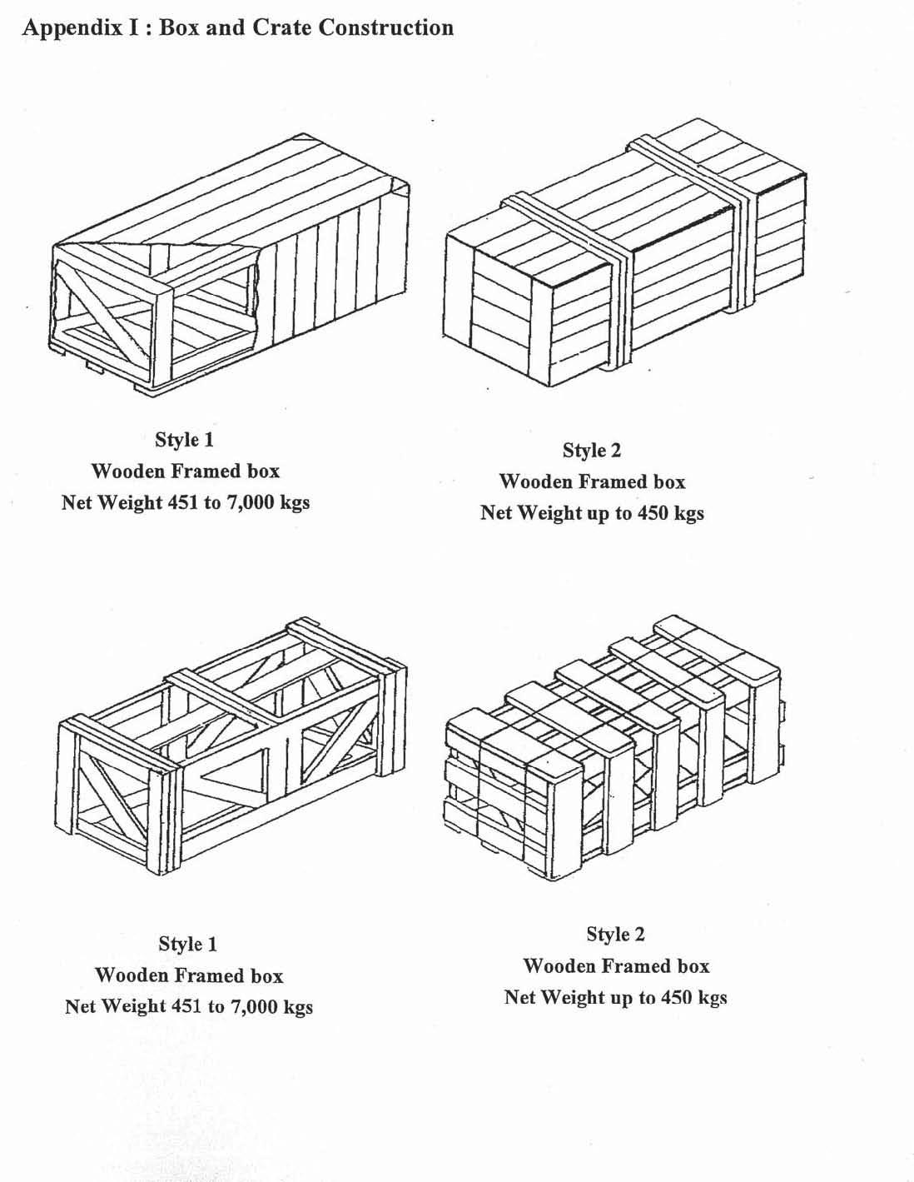
Reference Only, the Supplier will pack per industry standards suitable for export packaging.
Reference Only, the Supplier will pack per industry standards suitable for export packaging.

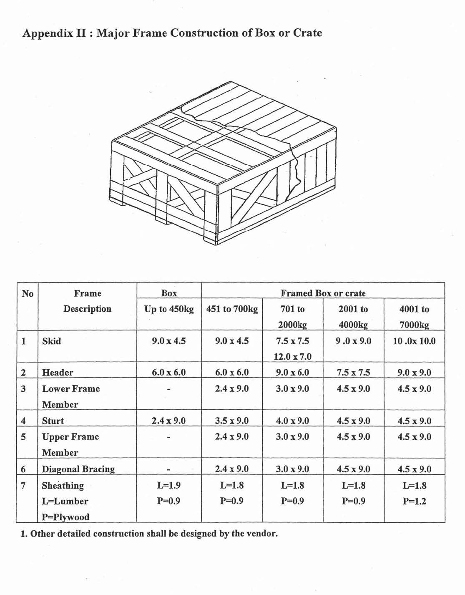
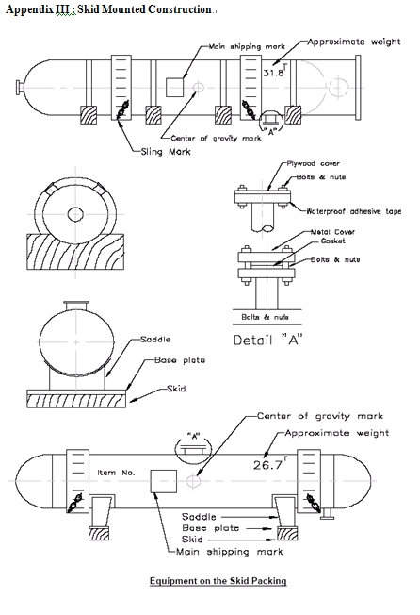
Reference Only, the Supplier will pack per industry standards suitable for export packaging.
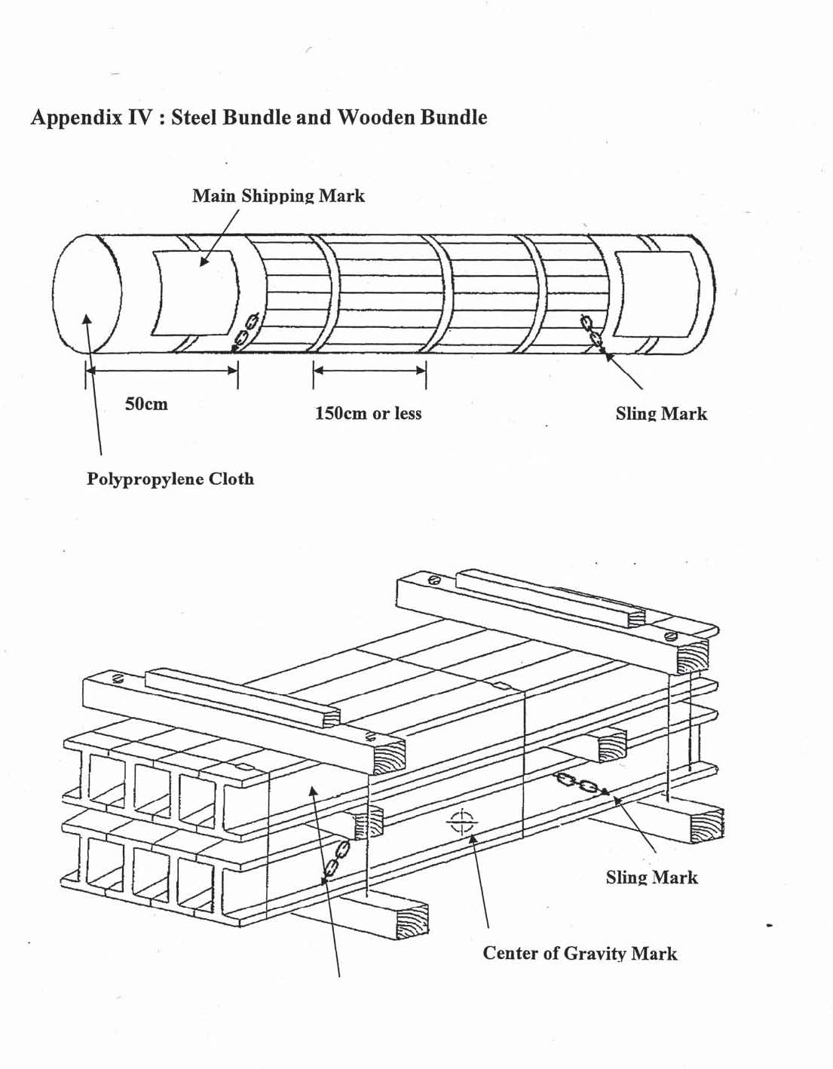
Reference Only, the Supplier will pack per industry standards suitable for export packaging.
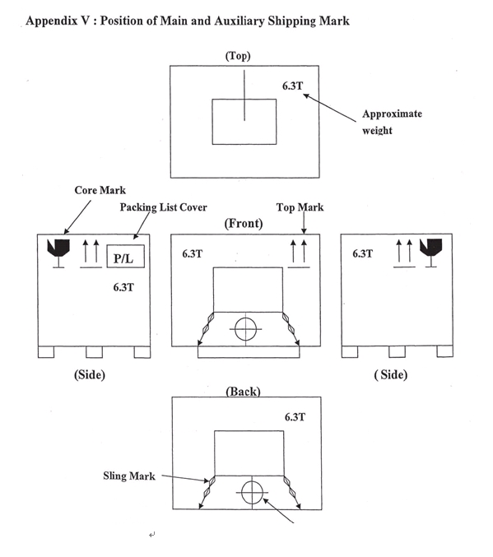
Reference Only, the Supplier will pack per industry standards suitable for export packaging.
