FREQUENTLY ASKED QUESTIONS - Rev 03
Q- Should the LCR LTL tool be used for B&W related shipments but B&W is not the Freight payer?
- No, the tool is designed only for when B&W (or anyone of its subsidiaries as listed below) is the freight payer. Please follow the instructions on the PO.
  - Babcock & Wilcox Company
  - Babcock & Wilcox Company (formerly Diamond Power)
  - Babcock & Wilcox Construction Company
  - Babcock & Wilcox Power Generation Group Canada Corp.
  - Babcock & Wilcox SPIG, Inc.
- What are the changes in PO clauses P7150, P7151 and P7150WP?
- There is no change in the verbiage printed on the PO for the clauses P7150, P7151 and P7150WP. These clauses direct you to the “BOX” where the verbiage is changed. Please read the verbiage on the PO and in the “BOX”.
Q- Should the LCR LTL tool be used for a Parcel shipment?
- No, the tool should never be used for any Parcel shipment, i.e. less and equal to 8 FT long and less than 150 Lbs. Please read and follow the routing guide, sections 1 & 2.

Q- What are the limitations for which the LCR LTL tool be used?
- Excluding parcel shipments; the LCR LTL tool should only be used for shipments less than 10,000 Lbs., with no single piece exceeding 13FT long or 7FT wide or high and 5000Lbs. Please read and follow the routing guide, section 3.

Q- Should the LCR LTL tool be used for a Truck Load (TL) shipment?
- No, the tool is not meant for TL shipments at all therefore it should never be used for any TL shipment. Please read and follow the routing guide, section 4.

Q- Is the LCR LTL tool a complete routing guide?
- No, the complete routing guide is on the PO (or as per attachment). The tool is one component of the routing guide. Please read, understand and follow the complete routing guide.

Q- Does the tool give suggested carriers for LTL shipments to / from Canada or Mexico?
- No, the tool is currently limited to Intra USA LTL shipments only.

Q- Does the tool give suggested carriers for LTL shipments to / from AK or PR or HI?
- No, the tool is currently limited to contiguous USA LTL shipments only.

Q- Is it important to select (check mark) the additional services (accessorials), if applicable, as it is showing optional?
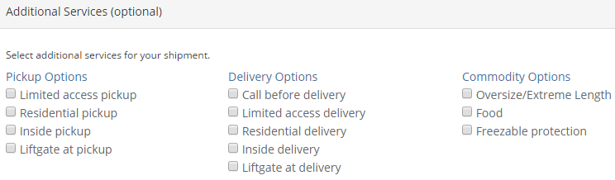
- Yes, the additional services, if applicable, MUST be selected (checked marked) otherwise the tool will not determine the right carriers.

Q- What should be done if additional services (accessorials) are applicable but are not listed in the tool?
- Please contact B&W Transportation as per routing guide.

Q- Should the “Service Time” on the output screen be used for time sensitive delivery?
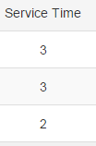

- No, Service Time (in days) is for general purpose only and it should not be used for time sensitive delivery. Please read and follow the routing guide for time sensitive delivery.

Q- CT Logistics manual shows actual rates of the carriers, why are those not seen on the screen?
- B&W has signed confidentiality agreements with the carriers not to disclose the rates of the carriers.

Q- Are BOL, Quotes and Templates features accessible / available?
- No, these features / tabs are not accessible / available.

